Structure of Mediation

- A neutral third party assists in the negotiation of an agreement between parties who could not come to an agreement on their own.

Hybrid of negotiation and arbitration

Mediation is like negotiation in that:

- its success ultimately depends on agreement between the parties.

- no third party has the authority to force a solution.

Mediation is like arbitration in that:

- neutral third party involved and “leading” the parties.

- financial investment into alternative dispute resolution techniques put in by both parties.

What Mediators Do and What Mediators Don’t

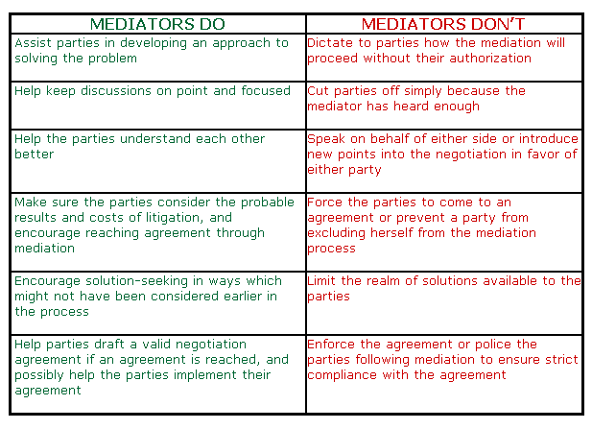

Mediation- Advantages

- Speed
- Faster than litigation or arbitration because those require hearings, presentation of witnesses, etc.
- Can be faster than negotiation because it is more focused.

- Inexpensive (compared to litigation or arbitration).

- Simplicity
No complex rules or procedures that need to be followed.

- Ability to “change on the fly”; not locked in by pleadings or motions.

- Flexibility in finding settlements and solutions.

- Settlement terms more likely to be agreeable to both parties.

Mediation- Disadvantages

- No guaranteed result, after the time and expense is put in to set up the mediation process.

- No procedural rules to guide the parties, no real way to discern credible evidence, etc.

- Little or no due process protections are available to either party

- No legal precedent is binding on and no legal precedent is set during negotiation.

- Lack of formal discovery mechanism can make it difficult to investigate during a mediation process.

- Because of these factors, mediation is often commenced after a lawsuit has been filed in civil court, allowing the civil court system to enforce some of these characteristics.

