Federal Reporters
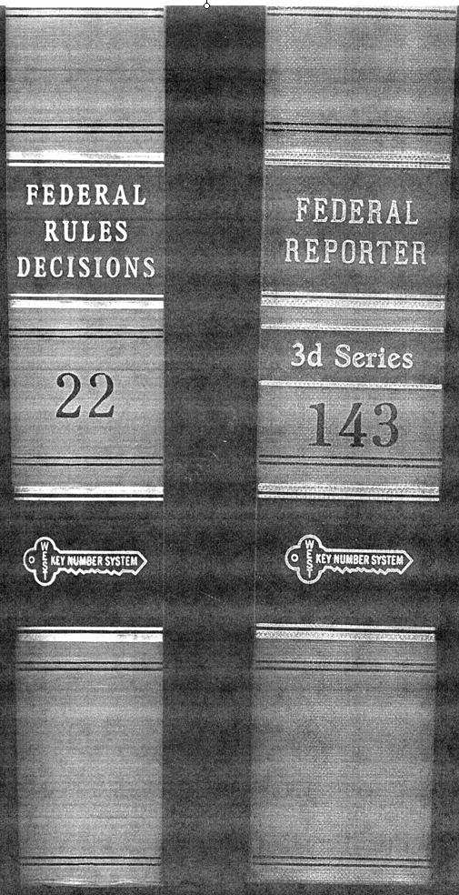
New York Case Reporters
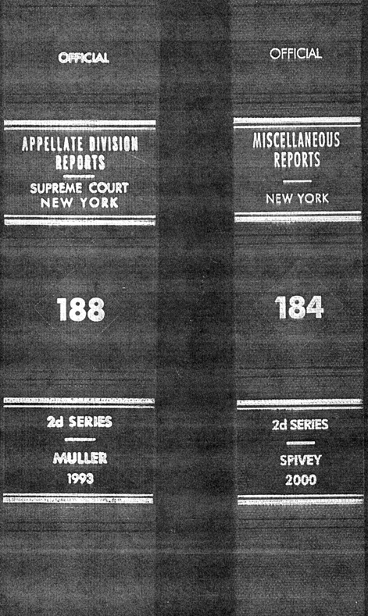
Federal Reporter - Appendix
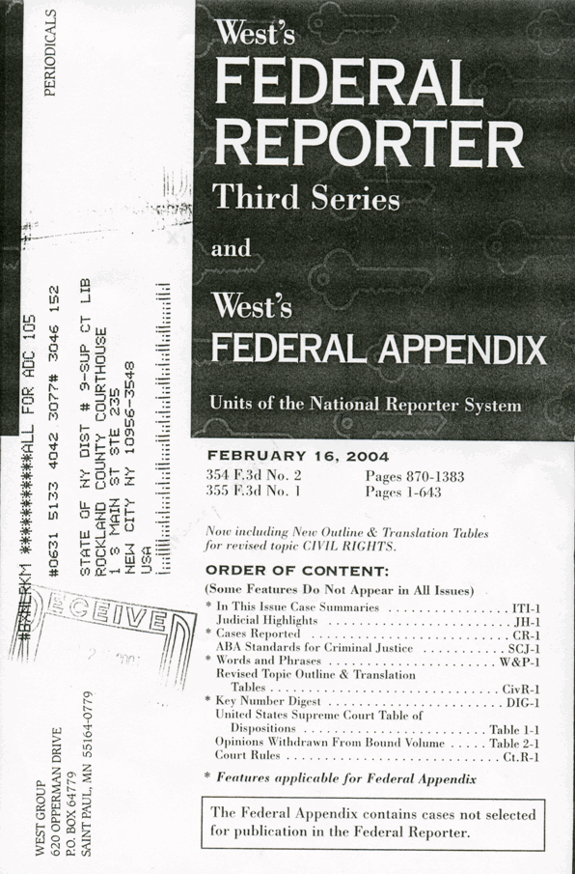
Federal Reporter - Index 1
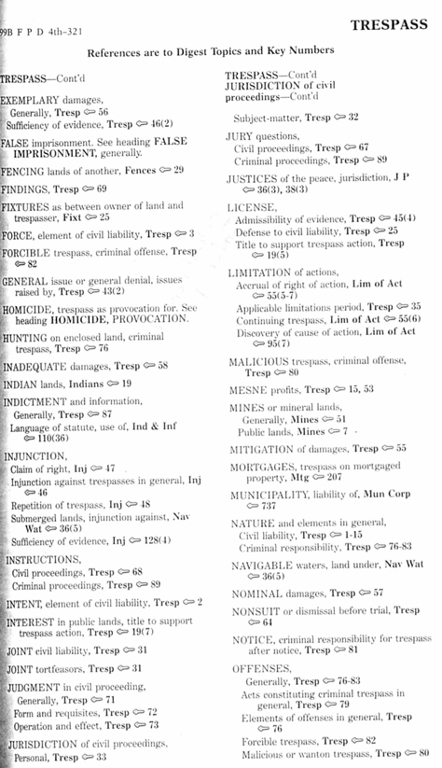
Federal Reporter - Index 2
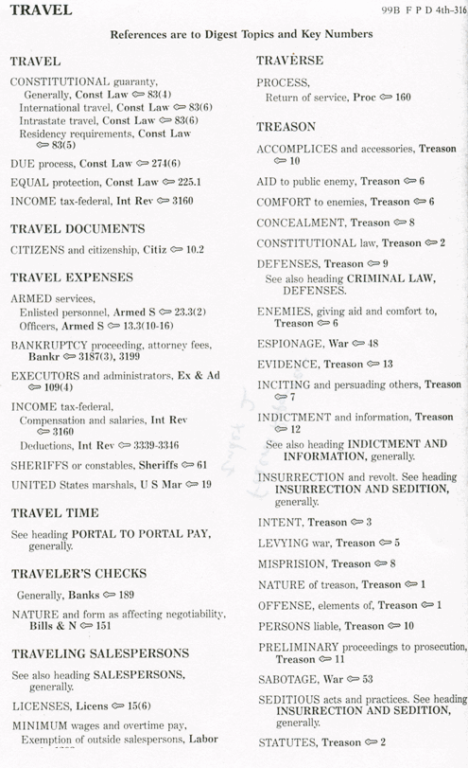
Federal Reporter - Descriptive Word Index

Federal Reporter - Abbreviation of Courts
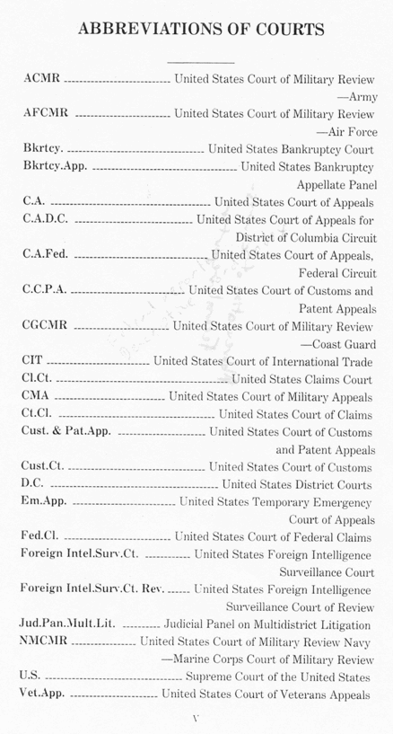
Table of Cases - Cover

Table of Cases - Inside
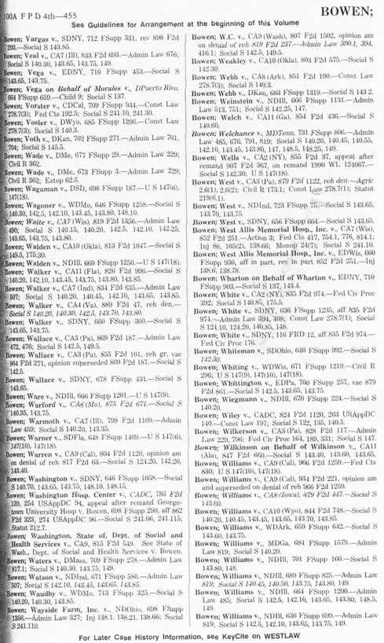
Federal Practice Digest - Cover
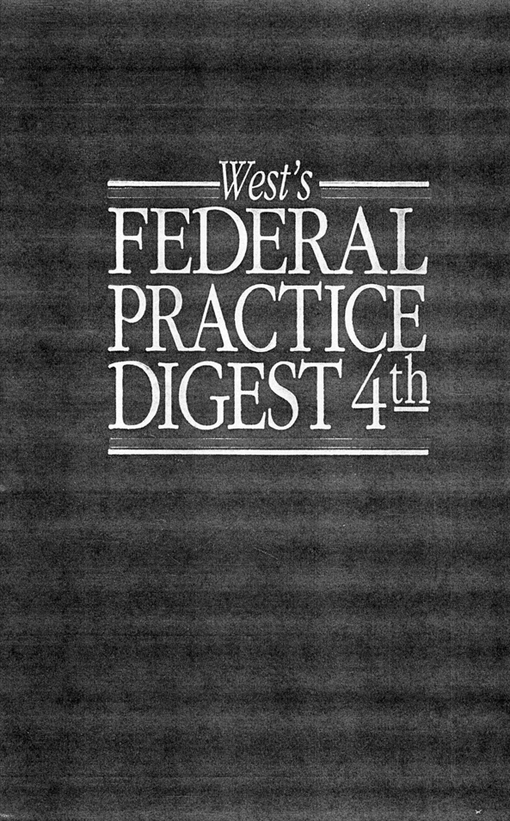
Federal Practice Digest - Inside 1
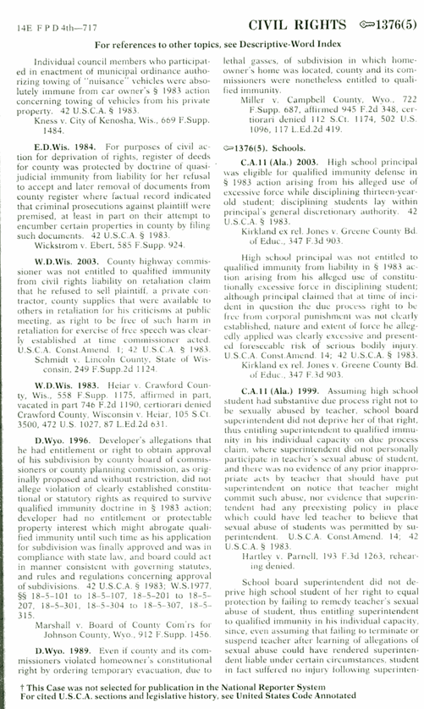
Federal Practice Digest - Inside 2
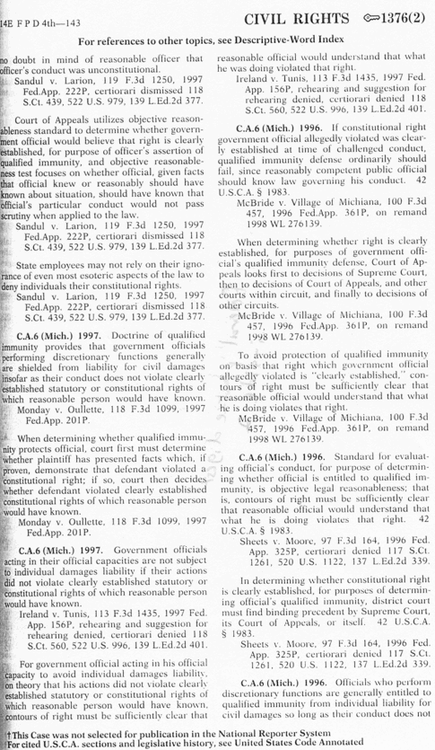
Federal Practice Digest - Back

Case from Federal Rules Decisions
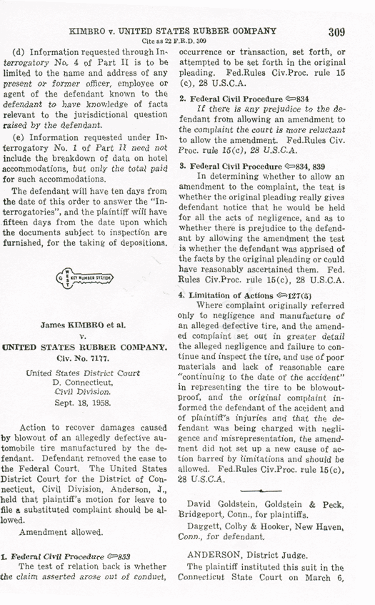
Federal Case - Title
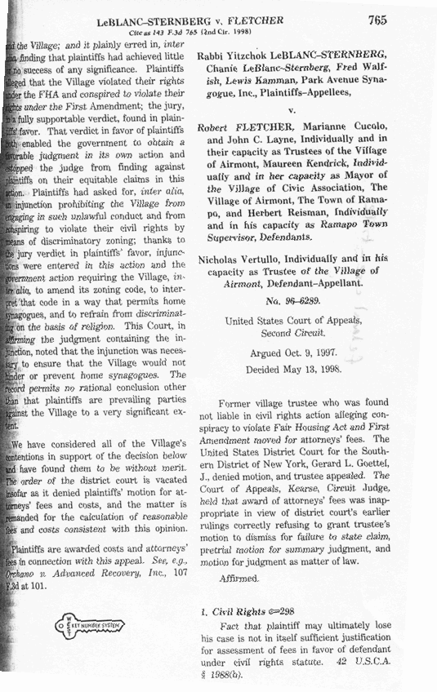
Federal Case - Keynotes
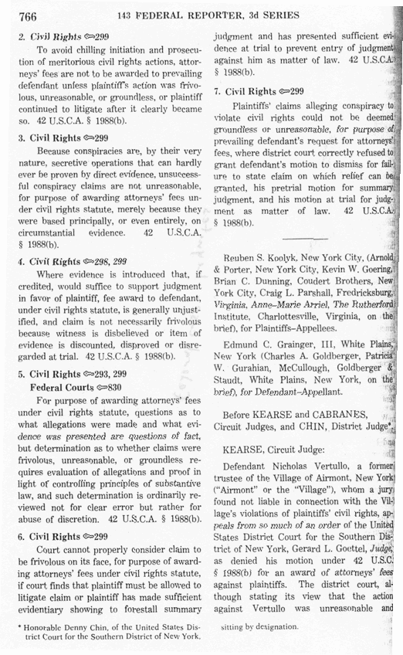
Federal Case - Background
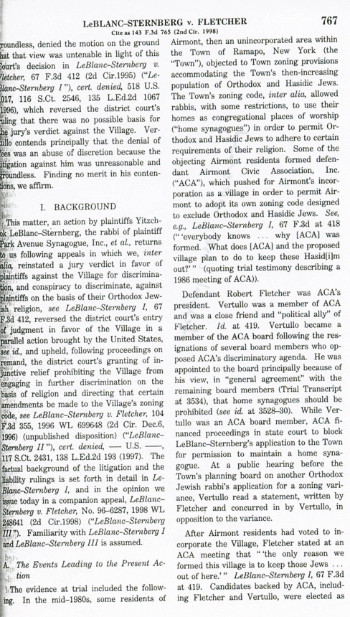
Federal Case - Discussion
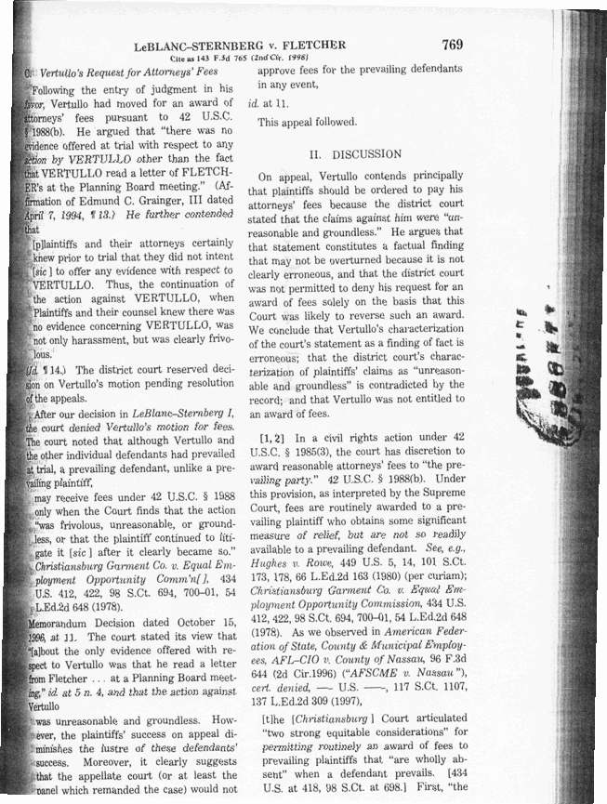
Federal Case - Conclusion
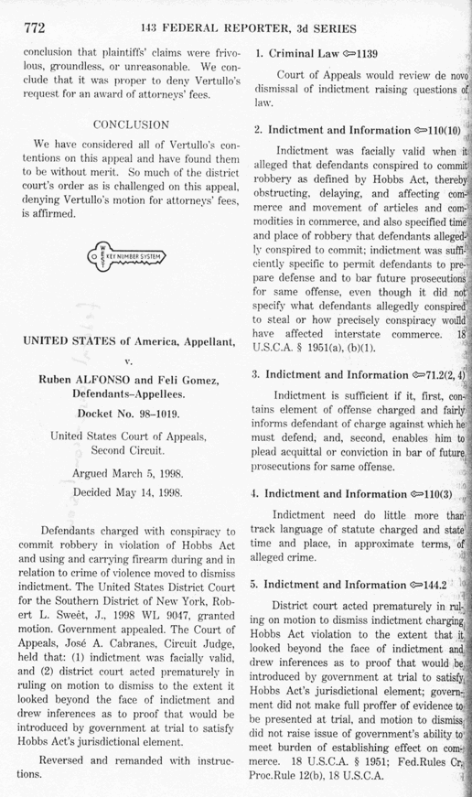
Hornbook – Inside
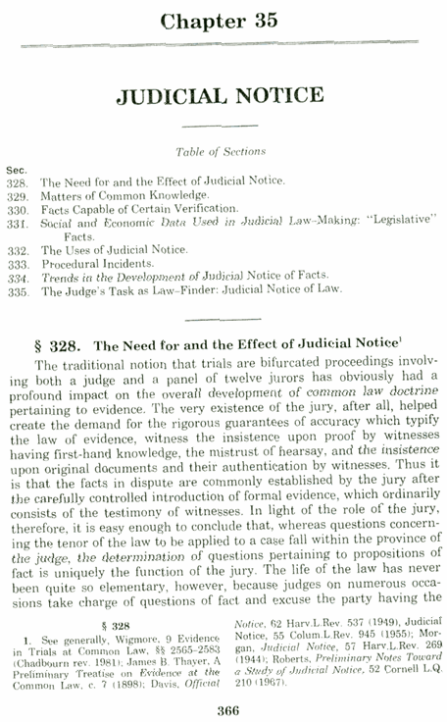
Hornbook - Outside
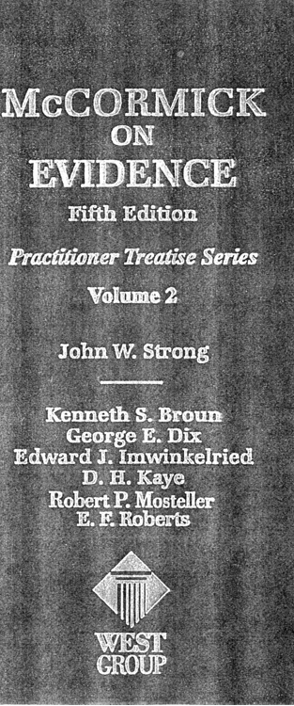
Statute - Volume - Outside
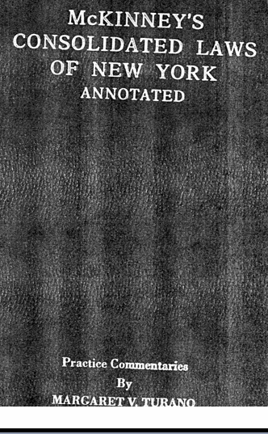
Statute - Notes of Decisions - Table of Contents
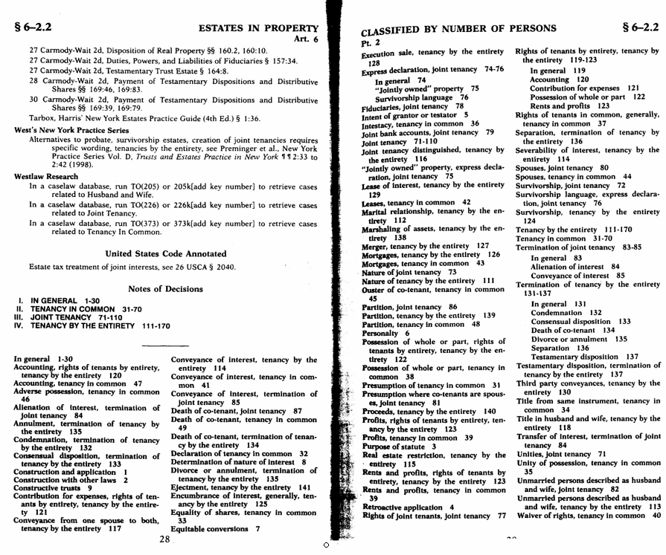
Statute - Inside
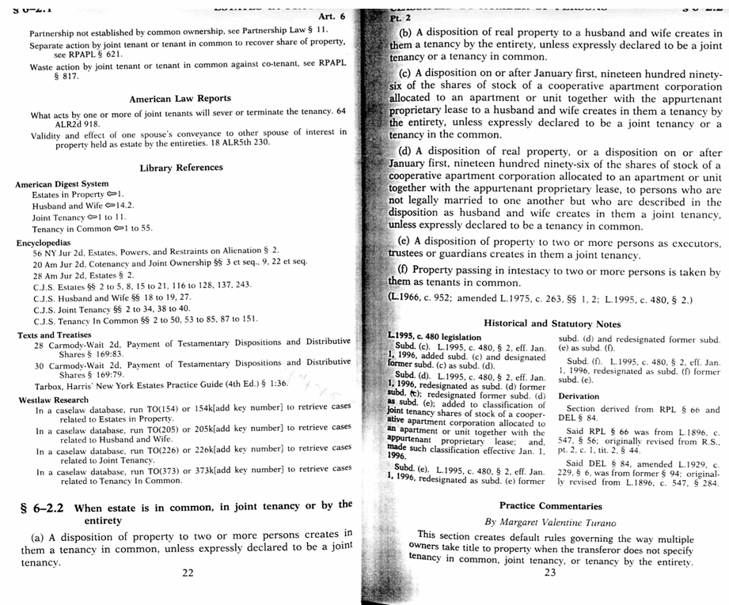
Statute - Case Notes
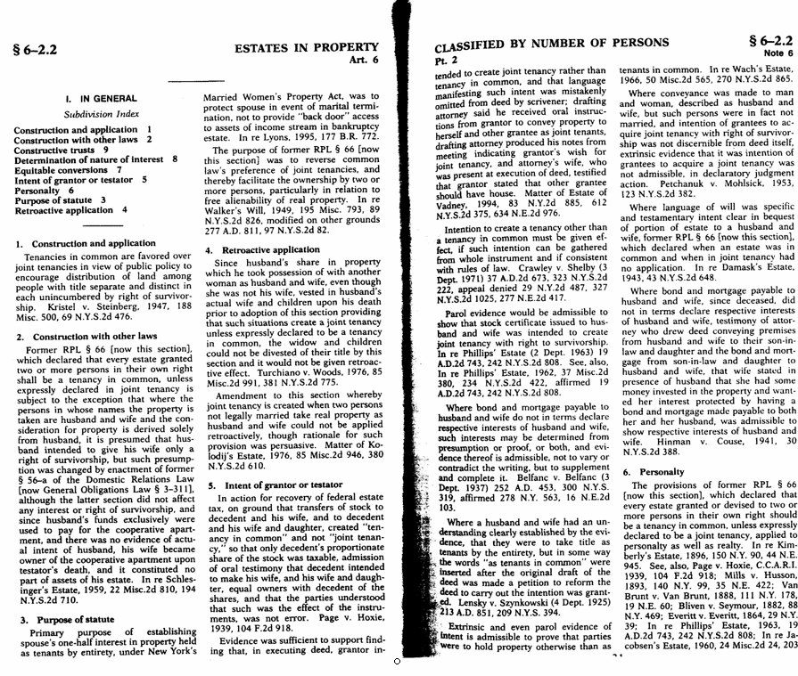
Attorney General Opinions


